**Project Design Phase 2**

**Data flow diagram and user stories**

|  |  |
| --- | --- |
| Date | 19 September 2022 |
| Team ID | PNT2022TMID13417 |
| Project Name | Estimation of crop yield |
| Maximum Marks | 4 Marks |

**Data Flow Diagrams:**

A Data Flow Diagram (DFD) is a traditional visual representation of the information flows within a system. A neat and clear DFD can depict the right amount of the system requirement graphically. It shows how data enters and leaves the system, what changes the information, and where data is stored.

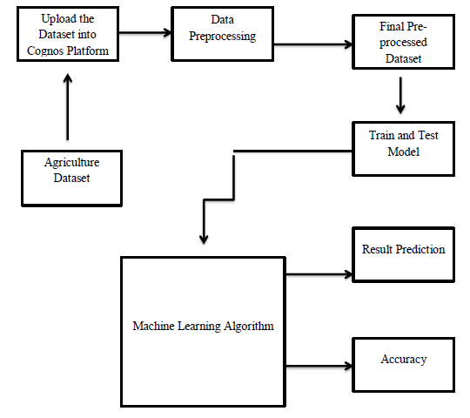

**User Stories:**

|  |  |  |  |  |  |  |
| --- | --- | --- | --- | --- | --- | --- |
| User Type | Functional Requirement (Epic) | User Story Number | User Story / Task | Acceptance criteria | Priority | Release |
| Customer (Mobile user) | Registration | USN-1 | As a user, I can register for the application by entering my email, password, and confirming my password. | I can access my account /dashboard. | High | Sprint-1 |
|  |  | USN-2 | As a user, I will receive confirmation email once I have registered for the application. | I can receive confirmation email & click confirm. | High | Sprint-1 |
|  |  | USN-3 | As a user, I can register for the application through Facebook | I can register & access the dashboard with Facebook Login. | Low | Sprint-2 |
|  |  | USN-4 | As a user, I can register for the application through Gmail. |  | Medium | Sprint-1 |
|  | Login | USN-5 | As a user, I can log into the application by entering email & password |  | High | Sprint 1 |
|  | Dashboard | USN-6 | Can use the methods provided in the  Dashboard. |  | Medium | Sprint 2 |
| Customer (Web user) | Activity | USN-7 | I can register for the application through any  web browser. | I can get an notification from the browser. | Low | Sprint 1 |
| Customer Care Executive | Access resources | USN-8 | I can use my credentials For accessing my  Resources. | Other than me, there is less chance to access my  Resources. | High | Sprint 1 |
| Administrator | Satellite visioning | USN-9 | As, a user I can vision the geographic area. |  | Medium | Sprint 2 |
| Customer tools | Tools | USN-10 | I can perform analysis by tools (cognos and  with ML) | I have an ease of  Accessing tools. | High | Sprint 1 |